# What a raycast is and when it is useful

A Raycast is a ray that ‘shoots’ out from wherever it is anchored. It has a variety of uses, one of which is detecting when the player is looking at something. In the block pushing game we used it by connecting it to the camera, which then allowed us to detect if we were looking at the block. If we were looking at the block, and close enough to it, we can then pick the block up. Another example of raycasts (maybe) is in Overwatch with a character like Ana. If she has a full ultimate charge, she can look at a teammate and a button prompt will come up allowing her to use her ultimate on the teammate. One way they could have done this is with a super long raycast that shoots out of Ana’s face and detects when it’s hitting a teammate.

# How to get objects that have been hit with a raycast

All it takes to get an object that’s being hit by the raycast is a couple of lines of code.

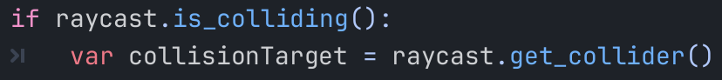

This if statement simply checks if the raycast is colliding with anything and, if it is, sets the variable collisionTarget to whatever is colliding with it.

# Uses of joints in games

In this game, the joint is used as a connector between the player and the box. It’s a simple way to connect, and disconnect, two physical objects together. Joints can be used to pick things up, like in Skyrim when you hold a bucket.

# Potential pitfalls of using joints

One pitfall of using joints is that, without some extra tweaking, the connection of the two objects is super loose. This makes it very difficult for the player to have a good sense of control over whatever is being connected. They also don’t seem to do any reparenting, which could lead to some difficulties with the structure of the game.